**Green Society Public School**

**D-20**

**Ratnanagar-7, Sauraha, Chitwan**

**First Terminal Examination-2082**

**Class: L.K.G Time: - 2 hrs. F.M.: 50**

**Sub: Maths P.M.: 18**

|  |
| --- |
| **Name: Roll No.: Sec.:** |
| **­­­­­­­­­­­­ ________________ ______________ OBT.MARKS:**  **INVIGILATOR EXAMINER** |

1. **Look at the pictures and tick (✔) the big animals. [2]**

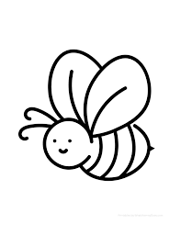 

** **

1. **Circle the biggest number. [4]**
2. **Draw the balls as per the given numbers. [4]**

**2 =**

**3 =**

**4 =**

**6 =**

1. **Count and write numbers. [5]**

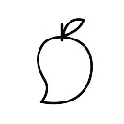 **=**

** =**

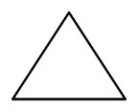 **=**



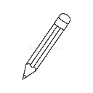 **=**



** =**



1. **What comes after? [5]**

**7 = _________ 14 = _________**

**8 = _________ 16 = _________**

**11 = _________ 20 = _________**

1. **What comes before? [5]**

**_________ 5 _________ 15**

**_________ 10 _________ 19**

**_________ 13**

1. **What comes in between. [5]**

**6 ______ 8 22 ______ 24**

**10 ______ 12 28 ______ 30**

**18 ______ 20**

1. **Join from 11 to 20. [5]**
2. **Match the same number. [6]**

31 34

32 35

33 36

34 31

35 32

36 33

**10) Write the missing numbers.** **[9]**

**१ २ _____ _____ ५**

**_____ ७ ८ _____ १०**

**_____ _____ १३ १४ _____**

**१६ _____ १८ _____ २०**

**The End**